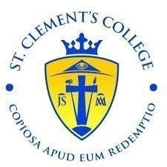  
**Book Grant information sheet for parents 2024/2025**

Book Grant forms are available to download from the St. Clements College website.

Please return book grant form to Niamh Canty and two pieces of **photocopied** evidence to the school by **Friday 17th May.**

**Medical card**

**And**

**Social welfare**  **or Family Income Supplement Slip (FISS)**

COLLECTION OF SCHOOL BOOK VOUCHERS

Once the book grant forms have been received with the correct supporting evidence. A voucher with a voucher number will be presented to you to use in Tony Clarkes Bookshop.

Please note the Book Vouchers will **NOT** be available for collection on any other day, only the allocated days and times.

**Collection Days in School for Tony Clarkes Book Vouchers for 4th (TY)-6th year students**

|  |  |
| --- | --- |
| **Date** | **Time** |
| Monday **27th May** 2024 | 12-3pm |
| Tuesday **28th May** 2024 | 10am- 1pm |

**Please note school book vouchers will need to be signed for and can only be collected by parent/ guardian.**

Thanking You,

Joan Chawke , Deputy Principal Niamh Canty, Outreach Support Worker